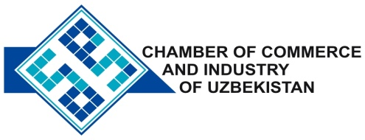

**Commercial offer of Uzbek Products to Foreign Buyer**

Dear Sirs, №SHP - 025

We offer quotation of Uzbek company LLC“MAER Textile “.

**Information about the company:**

The company " MAER Textile " was founded in 2007 . The company specializes in the manufacture of sewing and knitted products.

**List of products:**

Mickey

T-shirts

Shirts "Polo"

**Benefits:**

100 % Cotton , top quality .

**Terms of delivery:** FCA Tashkent

If you are interested, we are happy to provide additional information in accordance with your request.

E-mail: export@chamber.uz

Website: www.chamber.uz

Export Promotion Department.

Chamber of Commerce of the Republic of Uzbekistan.